EBIT Run August 1-4, 2017

Written by: Samuel Sanders and Roshani Silwal

**MOTIVATION AND GOALS**

1. Spectroscopy of highly charged tungsten has been of much interest due to their relevance in plasma diagnostics in fusion plasmas. With W being the plasma-facing material in the tokamak such as ITER, different research communities have investigated a wide wavelength region for highly charged tungsten. Several measurements in the extreme-ultraviolet [] and x-ray region [] have been performed over last few years. With the use of NIST EBIT, measurements in the EUV region were performed and line identification measurements were performed for W39+ to W47+ [], W54+ to W63+ []. Berlin EBIT [] measured the soft x-ray lines at 0.56 nm/ 2.214 keV from Cu-like W45+ to Cr-like W50+ ions originating from 3d-4f transitions, using a high resolution x-ray flat-crystal Bragg spectrometer. LLNL EBIT measured the x-ray M-shell spectra of W ions from Se-like to Cr-like W. No x-ray transitions are reported for the x-ray line at 2.414 keV corresponding to the transition 3d3/2 - 4f5/2 from the V-like W []. We intend to measure the transitions for higher states of W beginning at V-like W with the crystal spectrometer.

In addition to the line identification measurements, dielectronic recombination measurements were successfully conducted with the NIST EBIT recently with the use of a germanium detector. Multiple DR, RR, DE features were identified for the beam energies between 6 keV and 10 keV. We are interested to measure the DR radiations with the high resolution crystal spectrometer in the photon energy range of 2.219 keV and 4.592 keV (decided by the energy range with the currently installed Si (111) crystal).

Series of resonances corresponding to DR processes involving transitions 2l-3l’and 2l-4l’ subshells in in Ne-like through Mn-like tungsten were measured by Ge detector in May, 2016. But these transitions correspond to the photon energy of 7 keV and higher. In this work, we are particularly interested to measure the 3l-4l’ secondary transition, where instead of the electron jumping from 4 to 2 emitting a high photon energy (11-12 keV), a subsequent emission follows where the electron first jumps from 4 to 3 and then to 2 (7.5-8 keV), thus emitting photons with lower photon energies (3-4 keV).

1. Following the unsuccessful attempt in June 2017 for the polarization measurements of the He-like Ar w, x, y, and z spectral lines, several changes and investigation of the vertical crystal spectrometer were conducted using an electron gun source exposed to a Sc target. Sc k alpha lines were measured and a series of systematic tests on the crystal spectrometer was done prior to the installment of the spectrometer back to the EBIT. A systematic investigation of the line shape and position was performed by changing the crystal Bragg angle, radius of the Rowland circle and the position of the crystal in the holder. In addition, an extension of 3” was added between the spectrometer and the CCD camera to increase the detector arm such that the detector would lie closer to the Rowland circle. The crystal spectrometer has polarization selective energy dispersion and with one spectrometer placed parallel to the electron beam and the other placed perpendicular, measurement of the polarization effects become straight forward. Furthermore, the non-Maxwellian collisional radiative code (NOMAD) developed to simulate the EBIT plasma and to understand the atomic processes inside the trap isn’t able to calculate the effect of polarization in our measurements in the x-ray region yet. With the availability of experimental results, our theoreticians believe to improve their models by adding polarization to match the measurements better. In addition to the He-like Ar transitions, a strong transition corresponding to the dielectronic capture by He-like Ar therefore creating Li-like Ar was measured at the beam energy of 2.85 keV. The transition corresponds to the radiative decay from doubly excited 1s2l3l’ to 1s23l. This transition was strong at the photon energy of 3.2 keV. We intend to measure polarization effects for these transitions as well.

**Experimental setup:**

The primary measurement were taken with the x-ray detectors: Ge detector and crystal spectrometer. Details of the spectrometers and MEVVA have been given in EBIT run report_06132017 []. Spectra were also recorded with the EUV spectrometer simultaneously at the CCD position of 1.25” (1.8 nm to 15.4 nm). The vertical crystal spectrometer was attached to the EBIT port on day 3 of the experiment. The roughing valve was replaced with a secondary all-metal gate valve and the section between the EBIT gate valve and the beryllium window was pumped through the secondary valve for couple of days.

**Day 1 (08/01/2017):**

We extrapolated the strongest transition corresponding to the 3d-4f transition from the theoretical spectra shown in figure 1 for Ge-like W through V-like W [] and measured the V-like W and Ti-like W spectra with the crystal spectrometer. The center of the detector was set at the energy of 2.459 keV (sine of the crystal Bragg angle = 0.8040) such that we will be able to measure the V-like W line to the left of the center and Ti-like W to the right of the detector.

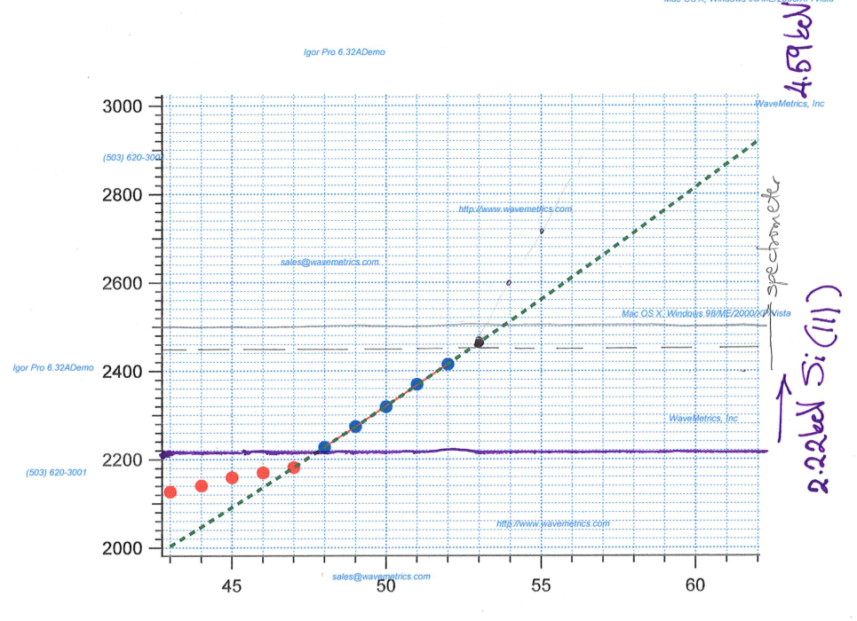

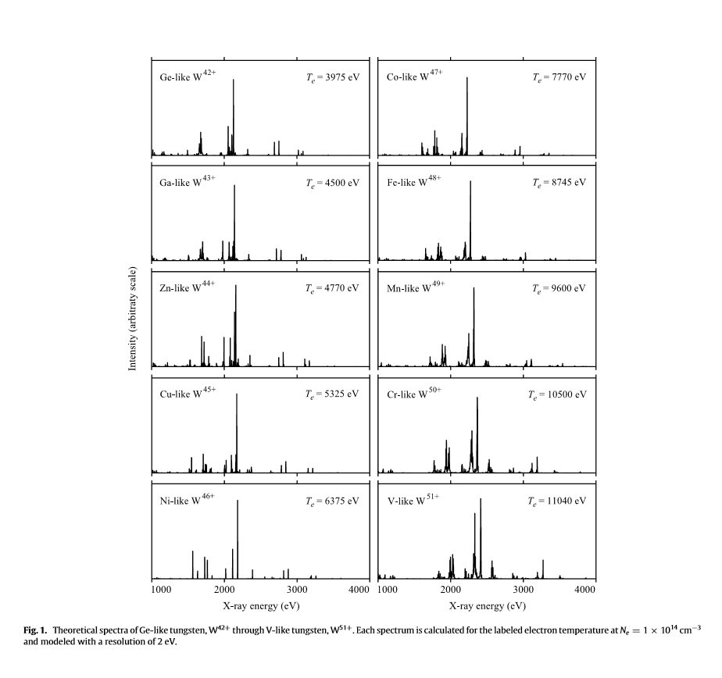

On day 1, we were unable to capture the MEVVA ions for couple of hours. We did a systematic investigation of the signal by varying the MEVVA floating voltage, MEVVA delay and the shield voltage during the capture. However, we weren’t able to capture the ions as monitored by the Ge detector and the EUV spectrometer. We monitored the trigger signals in the oscilloscope for the shield and MEVVA, and were able to identify that the function generator was reading a constant shield voltage instead of running the steps applied so that the shield voltage jumps from one value to next to the match the MEVVA voltage. After talking to Joseph’s group who conducted run prior to our experiment, we realized that the BNC cable to the shield was replaced by the Paul trap cable. Due to this, the trigger to the function generator which runs the sequence of shield settings during trapping was never sent and we weren’t able to capture the MEVVA ions. The voltage setting that runs through the function generator is in the table below:

|  |  |  |
| --- | --- | --- |
| Time (ms) | Timing | LabView Voltage |
| 0 | 0 | V |
| 0.5 | 100 | V |
| 2 | 400 | 3.1402 |
| 10.5 | 2100 | 3.1402 |
| 12 | 2400 | V |
| 12.5 | 2500 | V |

An example of how the timing setting works is shown in the plot below.

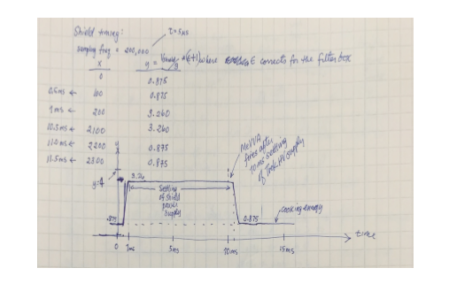

**Day 2 (08/02/2107):**

To begin with, the center of the detector was set at the energy of 2.459 keV (sine of the crystal Bragg angle = 0.8040) such that we will be able to measure the V-like W line to the left of the center and Ti-like W to the right of the detector. We saw 2 strong peaks with the crystal spectrometer. Six spectra were recorded with the crystal spectrometer and the Ge detector for 3 minutes each and 5 minute collection was done with the EUV spectrometer. As we do not have calibration lines in this energy region, we decided to move the peak by few eVs to determine the dispersion relation and conduct a rough calibration based on it. As we moved the camera by 25 eV to of 0.7959 i.e. energy of 2.484 keV to move the peak to the left, the peak disappeared. This might be due to the fact that at lower photon energies, the range of the detector is small (≈ 80 eV for these x-ray energies). The range increases as we increase the photon energy by decreasing the value of . We observed new peaks to the right of the center of the detector for the new Bragg angle. These transitions is most likely from the Ti-like W. We will be able to confirm this after comparing the measured spectra with the calculated spectra generated using the non-Maxwellian collisional-radiative model NOMAD. Six spectra were recorded at this setting with similar exposure time as well. The beam energy was set at 5.2 keV and beam current of 140 mA was attained at this beam energy. The ionization energies of the V-like W and Ti-like W are 4.709 keV and 4.927 keV respectively. The beam energy was then changed to 5.4 keV and 5.2 keV to optimize the x-ray spectra. To calibrate the spectrometer, the peaks were walked through the detector in steps of 25 eV.



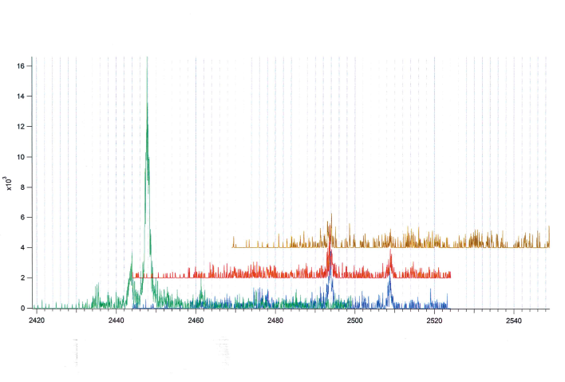

Since, we weren’t able to find lines in the background spectra or from other elements in the energy of lines of interest, we decided to move to the measurement of the DR radiative signals with the high resolution crystal spectrometer as well as the Ge detector. We continue to collect signals with the EUV spectrometer throughout the measurement. Multiple spectra were recorded at the shield voltage of 9.5 kV. Current of 129.9 mA was used during the measurement. Individual spectra of 3 mins were recorded with the x-ray detectors and 5 mins with the EUV spectrometer. The angle was set such that the center of the detector has the energy of 3.124 keV. The background spectra at this setting is set for the He-like Ar lines such that the w, x, y and z lines can be used for the calibration of the spectrometer. Since, we weren’t able to measure strong line features at this energy setting, we moved the crystal spectrometer to H-like Ar position (and collected spectra for beam energies of 9.5 keV and 9 keV.



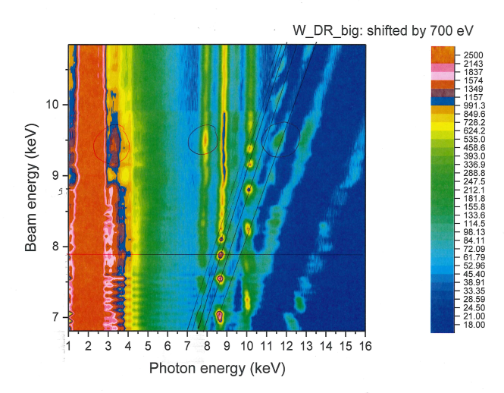

We are interested to measure the secondary 3l-4l’ DR transition with emission features at the photon energies of 3 4o 4 keV.

**Day 3 (08/02/17):**

Eleven W spectra at the beam energy of 9.1 keV was acquired including a background spectra at the sine of the crystal angle of 0.6028 (photon energy of 3.279 keV). The intensity of the W signal was monitored with the Ge detector by changing the beam energies in between 8.5 keV and 10 keV. Another region of interest where we observe a strong DR feature was chosen from the contour plot and the beam energy was varied from 7.5 keV to 8.5 keV. The signal was most intense at the shield voltage of 7.9 keV.



Multiple spectra were recorded at the shield voltages of 7.8 keV and 7.9 keV.



We then moved back to the energy scan from 9.2 keV through 10 keV at the steps of 100 eV and measured 6 spectra at each settings. 



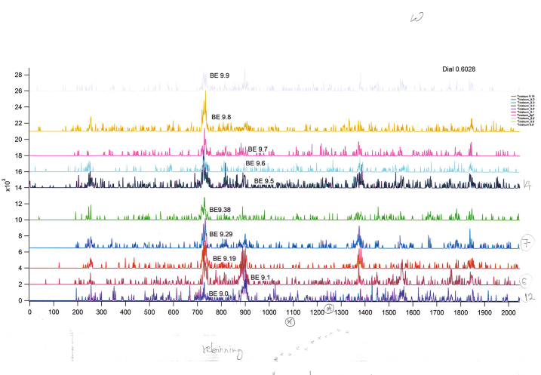H-like Ar 1s-2p1/2 and 1s-2p3/2 transitions are to be used to calibrate the crystal spectrometer. However, the transitions cover a narrow range of energy. We moved the peaks by 25 eV and measured the transitions for better calibration based on the readings of the encoder which is proportional to the sine of the Bragg angle of the crystal.

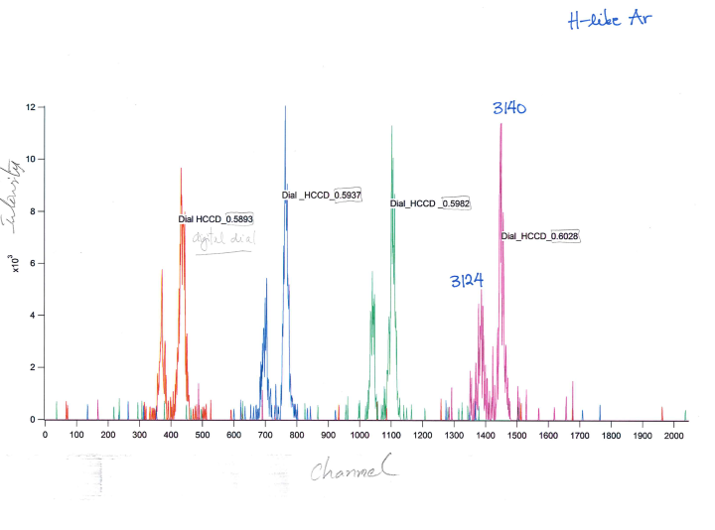

After the end of measurement on day 3, we opened the gate valve to the EBIT with the secondary valve closed. The e-gun pressure increased from 2.7 x 10-10 torr to 9 x 10-9 torr for an instant of time when the valve was first open. The e-gun pressure then dropped to around 4.6 x 10-10 torr and remained stable for the rest of the time. The crystal spectrometer was installed to the Be window with a bellow in between for flexibility during the installation of the crystal spectrometer and proper alignment of the crystal spectrometer.

**Day 4 (08/03/17):**

On day 4, the liquid helium ran out during the EBIT startup process. We managed to get another tank of 100 liter to continue with the measurement.

Polarization measurement for the He-like Ar line:



Polarization measurements for the n=2 to 1 DR line.

